Name : Zid’Avwa Al Bari’i

NIM : 244107020083

Class / Number : TI-2I / 26

Jobsheet 3

# First Set

## Code

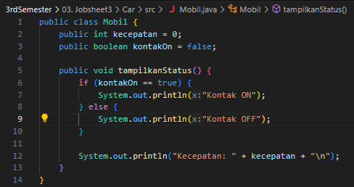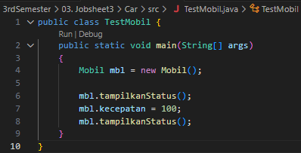

## Output



# Second Set

## Code

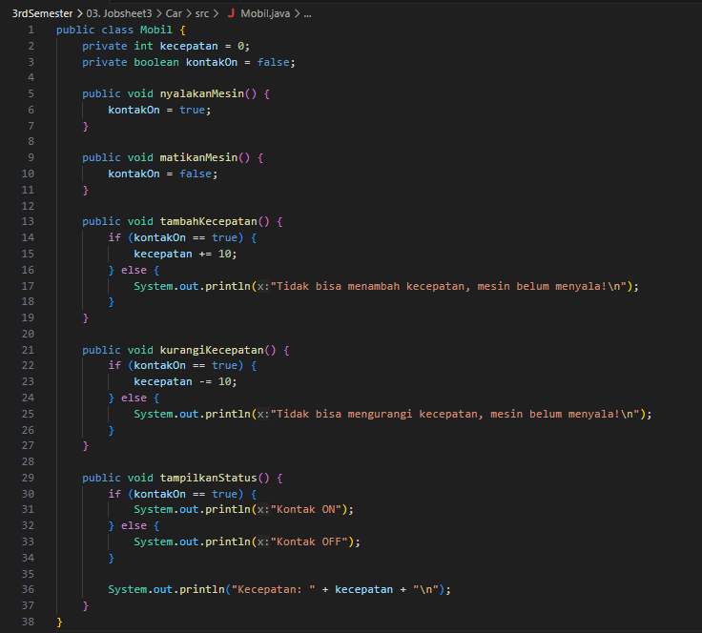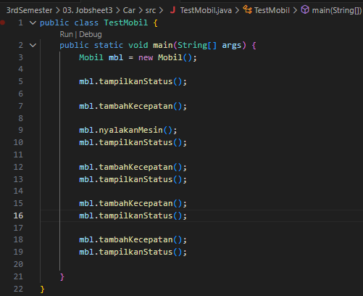

## Output



# Third Set

## Code

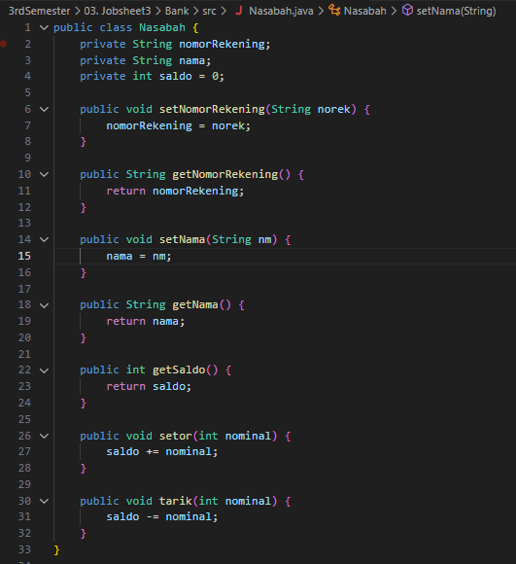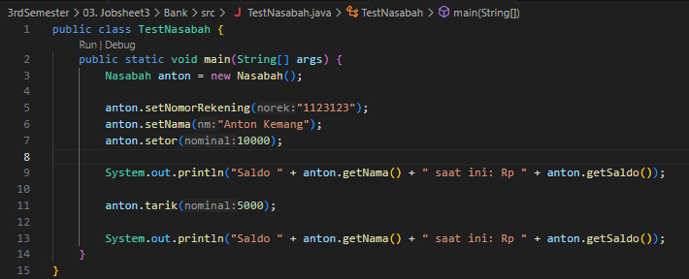

## Output



# Fourth Set

## Code

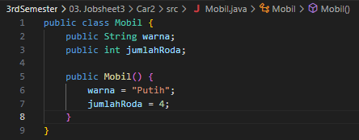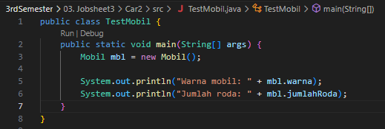

## Output



# Fifth Set

## Code Added



## Output



# Sixth Set

## Code

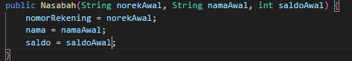

## Output



# Questions

1. **Purpose of encapsulation:**  
   To hide and protect data inside a class, so attributes cannot be changed freely but only through controlled methods.
2. **Example with encapsulation LibraryBook:**  
   In a library system, we don’t want anyone to freely change whether a book is borrowed or not.

* Attributes are private String title; private boolean borrowed;
* To change them, we provide methods:
  + borrowBook() : sets borrowed = true if available
  + returnBook() : sets borrowed = false
  + isBorrowed() : lets us check the status  
    This ensures the rules of borrowing/returning are followed.

1. **Example of a class to construct – Student:**  
   When creating a student object, we may want default or initial values directly.

* Attributes: name, id, age
* Constructor: public Student(String n, String i, int a) initializes the attributes at object creation.
* This way, every new student object is valid and already has its basic information set.